Week 5
Task 1
Aim: To find the maximum possible sum of a subarray in a circular array, considering both normal and wrap-around subarrays.
Algorithm:
- Use Kadane’s algorithm to find the maximum subarray sum.
- Use Kadane’s algorithm to find the minimum subarray sum.
- Compute the total sum of the array.
- Calculate circular sum as totalSum − minSubarraySum.
- If all elements are negative, return the normal maximum subarray sum.
- Otherwise, return the maximum of normal sum and circular sum.
Program:
class Solution {
public int maxSubarraySumCircular(int[] nums) {
int total = 0;
int maxSum = nums[0];
int curMax = 0;
int minSum = nums[0];
int curMin = 0;
for (int n : nums) {
curMax = Math.max(curMax + n, n);
maxSum = Math.max(maxSum, curMax);
curMin = Math.min(curMin + n, n);
minSum = Math.min(minSum, curMin);

total += n;
}

if (maxSum < 0) return maxSum;

return Math.max(maxSum, total - minSum);
}
}

Output:

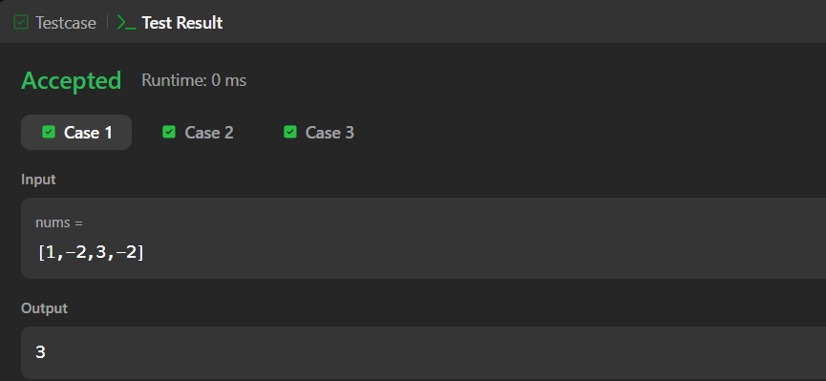

Result: To find the maximum possible sum of a subarray in a circular array, considering both normal and wrap-around subarrays has successfully verified.
Task 2
Aim: To find the number of contiguous segments of length m in the chocolate bar such that the sum of elements equals d.
Algorithm:
- Initialize count = 0 and sum = 0.
- Traverse the list from index 0 to n-1.
- Add the current element to sum.
- If window size exceeds m, subtract the element leaving the window (i - m).
- When window size becomes m, check:
  - If sum == d, increment count.
- After traversal, return count
Program:
class Result {
public static int birthday(List<Integer> s, int d, int m) {
int count = 0;
int sum = 0;
for (int i = 0; i < s.size(); i++) {
sum += s.get(i);
if (i >= m) {
sum -= s.get(i - m);
}
if (i >= m - 1 && sum == d) {
count++;
}
}
return count;

}}

Output:
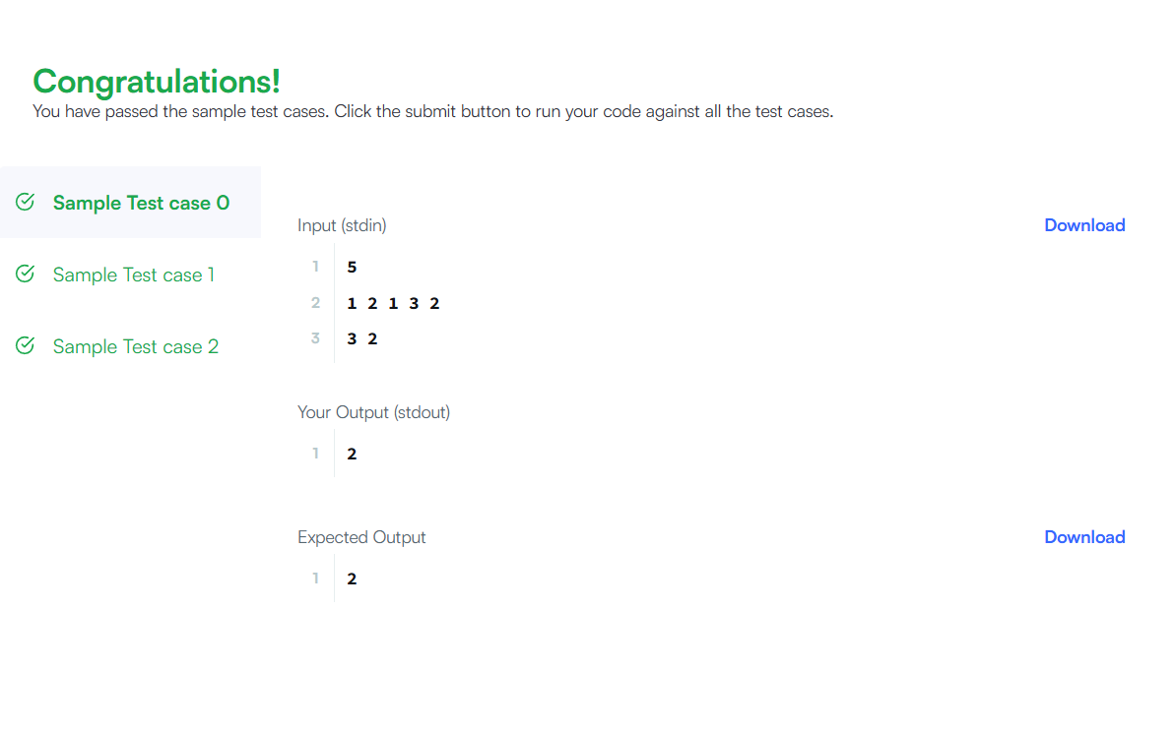

Result: To find the number of contiguous segments of length m in the chocolate bar such that the sum of elements equals d has successfully executed .
Task 3
Aim: To compute the maximum sum of a contiguous subarray and the maximum sum of a non-contiguous subsequence from a given integer array.
Algorithm:
- Initialize currentSum and maxSubarray with the first element.
- Traverse the array:
- Update currentSum = max(arr[i], currentSum + arr[i]).
- Update maxSubarray with the maximum value.
- For subsequence:
- Add all positive elements to maxSubsequence.
- Track the maximum element in the array.
- If no positive elements exist, set subsequence sum to the maximum element.
- Return both sums.
Program:
public static List<Integer> maxSubarray(List<Integer> arr) {
int maxSubarray = arr.get(0);
int currentSum = arr.get(0);
int maxSubsequence = 0;
int maxElement = arr.get(0);
for (int i = 0; i < arr.size(); i++) {
int val = arr.get(i);
if (i > 0) {
currentSum = Math.max(val, currentSum + val);
maxSubarray = Math.max(maxSubarray, currentSum);
}if (val > 0) {
maxSubsequence += val;
}

maxElement = Math.max(maxElement, val);
}

if (maxSubsequence == 0) {
maxSubsequence = maxElement;
} return Arrays.asList(maxSubarray, maxSubsequence);
}
Output:

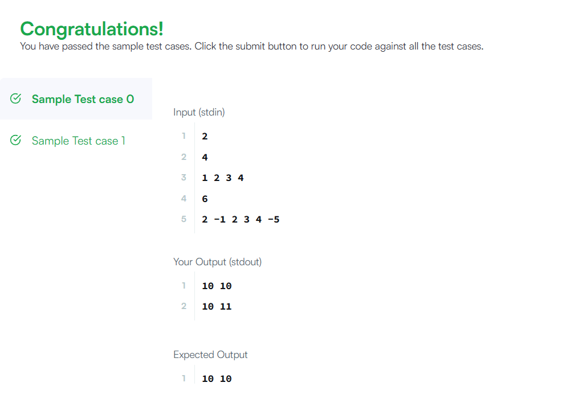

Result: To compute the maximum sum of a contiguous subarray and the maximum sum of a non-contiguous subsequence from a given integer array was successfully executed.
Task 4
Aim: To find the maximum sum of a contiguous subarray from the given integer array.
Algorithm:
- Initialize currentSum and maxSum with the first element.
- Traverse the array from the second element.
- For each element, update currentSum as the maximum of the current element or the sum of current element with previous sum.
- Update maxSum if currentSum is greater.
- Return maxSum.
Program:
class Solution {
public int maxSubArray(int[] nums) {
int currentSum = nums[0];
int maxSum = nums[0];
for (int i = 1; i < nums.length; i++) {
if (currentSum + nums[i] > nums[i]) {
currentSum = currentSum + nums[i];
} else {
currentSum = nums[i];
}
if (currentSum > maxSum) {
maxSum = currentSum;
}
}
return maxSum;
}
}

Output:

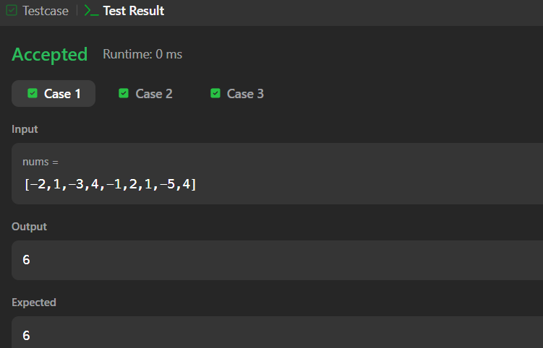

Result: To find the maximum sum of a contiguous subarray from the given integer array has successfully verified.
Task 5
Aim: Convert a given string into a 32-bit signed integer by handling spaces, sign, digits, and overflow.
Algorithm:
- Remove leading spaces using trim().
- If string is empty, return 0.
- Initialize variables
- sign = 1
- i = 0
- result = 0
- Check sign
- If '+' → positive
- If '-' → negative
- Move index forward.
- Traverse digits
- While character is digit, convert and build number
- result = result * 10 + digit
- Check overflow
- If result exceeds integer range, return Integer.MAX_VALUE or Integer.MIN_VALUE.
- Return final answer
- result * sign
Program:
class Solution {
public int myAtoi(String s) {
s = s.trim();
if (s.length() == 0) return 0;
int sign = 1;
int i = 0;
long result = 0;
if (s.charAt(i) == '-' || s.charAt(i) == '+') {
if (s.charAt(i) == '-') sign = -1;
i++;
}

while (i < s.length() && Character.isDigit(s.charAt(i))) {
result = result * 10 + (s.charAt(i) - '0');
if (sign * result > Integer.MAX_VALUE) return Integer.MAX_VALUE;
if (sign * result < Integer.MIN_VALUE) return Integer.MIN_VALUE;

i++;
}
return (int)(sign * result);
}
}
Output:
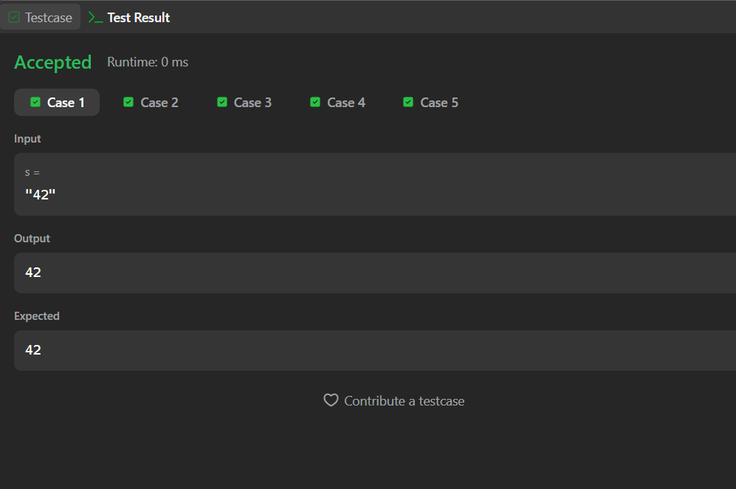

Result: Convert a given string into a 32-bit signed integer by handling spaces, sign, digits, and overflow has successfully executed.
Task 6
Aim: To find the minimum number of deletions required so that no two adjacent characters in the string are the same.
Algorithm:
- Initialize a variable count = 0.
- Traverse the string from index 1 to end.
- Compare current character with previous character.
- If both characters are the same, increment count (delete one character).
- After traversal, return count.
Program:
public static int alternatingCharacters(String s) {
int count = 0;
for (int i = 1; i < s.length(); i++) {
if (s.charAt(i) == s.charAt(i - 1)) {
count++;
}
}
return count;
}

Output:
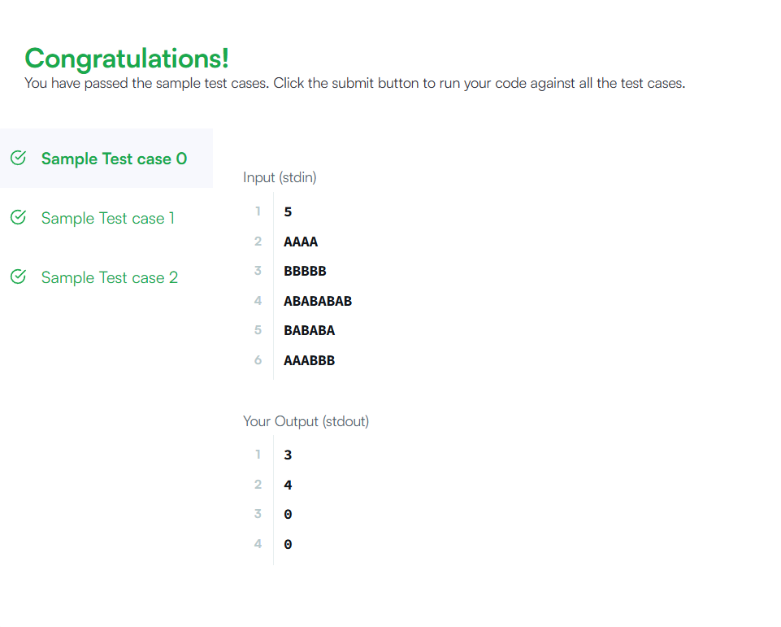

Result: To find the minimum number of deletions required so that no two adjacent characters in the string are the same has successfully executed.

